Patient/Family Advisors Orientation
“Sharing My Story: Worksheet”
Background
Sharing stories is an important way for us to tell others a little bit more about ourselves and provides listeners with the opportunity to learn about and from us and our experiences. Each person has a story to tell that is uniquely theirs; by listening carefully to these, we can gather insights about each other and better understand where we have come from and where we would like to go.
Name: __________________________________________________________________________

Please check the box that best describes your current/previous experience in the cancer system
- Person with cancer/survivor
- Family/friend/caregiver

A: Understanding your story:
Q1: What is the primary type of cancer for which you (or your family member/friend) are receiving/received cancer treatment/care?

Q2: Can you tell me about your experience with cancer or connection to the disease?

Q3: How was your cancer detected?

Q4: What feelings did you experience with your diagnosis? How did you cope with the news?

Q5: How did your family or friends react?

Q6: Are there any other aspects of your experience that you would like to share?

B: Understanding your perspective:
Q7: What is the ONE most important aspect about your experience that you would want others to know?

Q8: What were some of your negative and positive experiences in the cancer system? What could have been improved? Consider providing 1-2 examples.

Q9: Below is CCO’s cancer care continuum. We encourage you to use this visual as a guide to help you begin to shape the areas of quality improvement or system change that you wish to see based on your experience.

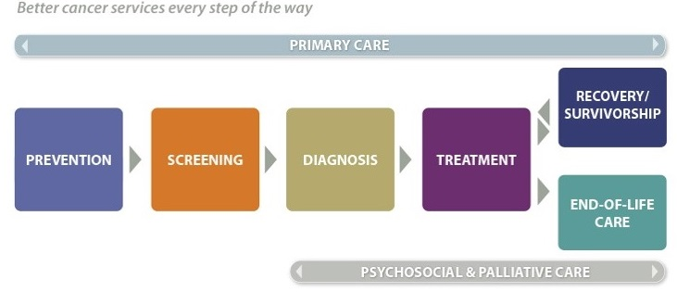

Considering this map coupled with your personal experience in the system, describe which aspect (1-2 areas) of the journey that you would like to see improvements in.

C: Understanding your motivation:
Q9: Based on your experience, what motivates you to be involved in system change as a Patient and Family Advisor?

Q10: What do you hope to achieve in your role as a Patient and Family Advisor?

