September 2019
Diagnostic Imaging Peer Learning Toolkit

4.2 Discrepancy Management Process Map and Standard of Work

4.2 Discrepancy Management Process Map
The process map below summarizes the steps required to confirm and resolve discrepancies identified through peer review. Customize the process by reviewing each step with the radiologist working group and answering the questions found on pages 2 to 5.
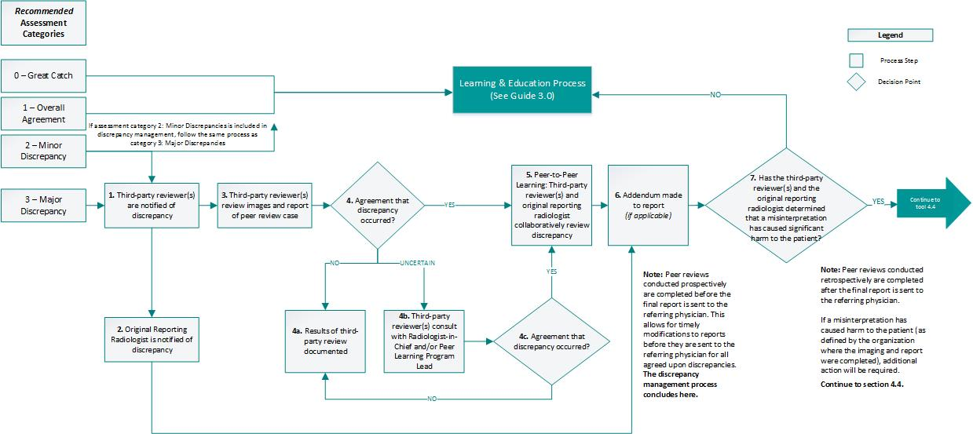
Figure 1: Discrepancy Management Process Map

Principles of Discrepancy Management Process:
- Anonymity: Aim to maintain anonymity between the original report radiologist and the radiologist completing peer review to maximize program participation and minimize concerns of a punitive process.
- Learning and Education-Focused: To maximize learning opportunities, your discrepancy management process should aim to promote collaborative decision-making around the confirmation of discrepancies and encourage peer-to-peer conversations, where possible.
- Accountability: Clearly defining key roles and responsibilities in the discrepancy management process will result in a timelier response to potential discrepancies. Discrepancies should not be managed by the original reporting radiologist alone.

4.2 Discrepancy Management Process Steps
Action | Key Decision
1. Third-party reviewer(s) are notified of discrepancy | - Which assessment categories will be included in the discrepancy management process (e.g., major and/or minor discrepancies)?  - Who will be the third-party reviewer(s) to receive the notification that a discrepancy has been identified? Will the third-party review be assigned to one or multiple individuals? Will third-party reviewers be consistent or randomized?  - How will the third-party reviewer(s) be notified of discrepancies?  - When will the third-party reviewer(s) receive notifications of discrepancies?  - What information will be included in the notifications?  - Will there be a process to manage third-party reviews in a timely manner in the event the intended reviewer is temporarily unavailable (e.g., vacation)?  For Cross-Organization Programs:  Use the 4.3x Cross-Organization Discrepancy Management Table tool to define cross-organization responsibilities.  Implementation Recommendations:  - The original reporting radiologist should be notified of the discrepancy as soon as possible to expedite any required follow-up and minimize any potential impact to patient care  - A third-party reviewer should immediately receive notification that a discrepancy has occurred in addition to the original reporting radiologist. It is recommended that the quality leads participate as third-party reviewers. This builds accountability into the process to ensure that necessary follow-up occurs with all discrepancies  - An organization may wish to have all discrepancies also sent to the radiologist-in-chief and/or the peer learning program lead. This will ensure that all follow-up on discrepancies is completed in a timely manner in the event the third-party reviewer(s) are temporarily unavailable (e.g., vacation) and provides the radiologist-in-chief and/or program lead an overview of program outcomes  - Information sent to third-party reviewer(s) could include, but is not limited to, comments from the peer review, rationale for assigning a discrepancy, and a mechanism to access the peer review case  - Anonymity should always be maintained between the original reporting radiologist and the reviewing radiologist. Anonymity will not be maintained between the original reporting radiologist and the third-party reviewer(s) in the event of a discrepancy to allow for peer-to-peer learning opportunities and the collection/dissemination of learnings
2. Original reporting radiologist is notified of discrepancy | - How will the original reporting radiologist be notified of discrepancies?  - When will the original reporting radiologist receive notifications of discrepancies?  - What information will be included in the notifications?  Implementation Recommendations:  - Radiologists should act as third-party reviewer only for cases that are reflective of their actual clinical practice  - The original reporting radiologist should be notified of the discrepancy as soon as possible to expedite any required follow-up and minimize any potential impact to patient care  - Information sent to original reporting radiologist could include, but is not limited to, comments from the peer review, rationale for assigning a discrepancy, and a mechanism to access the peer review case  - Anonymity should always be maintained between the original reporting radiologist and the reviewing radiologist
- Third-party reviewer(s) reviews images and report of peer review case | - Who will be accountable for the first review of the case when a discrepancy has been identified? Will the original reporting radiologist review the discrepancy prior to the third-party reviewer?  - Will the third-party reviewer(s) review the case separately or collaboratively with the original reading radiologist?  - Is there a specific timeframe for reviewing the case?  - How will third-party reviewer(s) access the original images and original report?  Implementation Recommendations:  - Third-party reviewer(s) should review the case immediately or as soon as possible in order to minimize any delays to patient care  - Alternatively, the original reporting radiologist should review the case immediately or as soon as possible and then inform the third-party reviewer(s) whether or not they agree that a discrepancy has occurred. If not, the third-party reviewer(s) can assess the case
- Is there agreement that discrepancy occurred? | - N/A
4a. If no: Document the results of the third-party review | - Will the results of the third-party review be documented? If so, where?  - What are the documentation requirements? Who is responsible for documenting?
4b. If uncertain: Third-party reviewer(s) should consult the radiologist-in-chief and/or the peer learning program lead | - Who will the third-party reviewer(s) consult if they are uncertain about the discrepancy?  - What will be the mode of communication used for consultation (e.g., email, telephone, in-person)?  - How will consensus be reached?  - What are the next steps if consensus cannot be reached?  - Are there any documentation requirements? Who is responsible for documenting?  Implementation Recommendation:  - If consensus cannot be reached, it is recommended that the third-party reviewer consult the radiologist-in-chief and/or program lead or another radiologist colleague
5. Peer-to-Peer Learning: Third-party reviewer(s) and the original reporting radiologist collaboratively review discrepancy | - How will the third-party reviewer(s) communicate with the original reporting radiologist?  - Is there a specific timeframe for discussion between third-party reviewer(s) and original reporting radiologist?  - If responsibilities for education and discrepancy management are held by different individuals, how will learnings be communicated back to the individual who leads the learning and education process?  Implementation Recommendations:  - Third-party reviewer(s) and original reporting radiologist should discuss the case immediately or as soon as possible to minimize any delays to patient care  - Learnings from discrepancy management should be shared with the individual who leads the learning and education process to ensure broad dissemination across the radiologist group
6. Addendum made to report (if applicable) | - Who will be responsible for adding the report addendum?  - How will the report addendum be communicated to the referring physician and/or patient?  Implementation Recommendation:  - It is recommended that the addendum be made by the original reporting radiologist
Note: Peer reviews conducted prospectively are completed before the final report is sent to the referring physician. This allows for timely modifications to reports before they are sent to the referring physician for all agreed-upon discrepancies. In prospective peer reviews, the discrepancy management process concludes at step 6. However, it is recommended that all organizations continue to tool 4.4 Incident Management Process Map and Standard of Work to ensure that an incident management process is in place for your peer learning program.

7. Has the third-party reviewer(s) and the original reporting radiologist determined that a misinterpretation has caused significant harm to the patient? | - How is harm defined by your organization?  - How will consensus be reached?  - What are the next steps if consensus cannot be reached?  - Are there any documentation requirements? Who is responsible for documenting?  Implementation Recommendation:  - Refer to your organization-specific policy for definition of patient harm  For Cross-Organization Programs:  The definition of patient harm and patient management should be based on the policies of the organization where the image and report were completed.  Decisions related to patient harm should be made by the original reporting radiologist and a representative from the original organization (e.g., third-party reviewer(s), radiologist-in-chief/program lead, etc.).
Has the third-party reviewer(s) and the original reporting radiologist determined that a misinterpretation has caused harm to the patient?
7a. If no: Consider including this case in your educational rounds. Refer to Guide 3.0, section 3.2: Define a Process for Radiologists to Collect and Discuss Learning Cases for more information.
Has the third-party reviewer(s) and the original reporting radiologist determined that a misinterpretation has caused harm to the patient?
7b. If yes: Continue to tool 4.4 Incident Management Process Map and Standard of Work.
Note: Peer reviews conducted retrospectively are completed after the final report is sent to the referring physician.
If a misinterpretation has caused harm to the patient (as defined by the organization where the imaging and report were completed), additional action will be required. Continue to section 4.4: Incident Management Process.

4.2 Discrepancy Management Process Standard of Work
Document your decisions from the questions posed on pages 2 to 5 in the Standard of Work template below. Once populated, this document can be used for training and communication purposes.

Key Roles in Peer Review Workflow Process:
- Quality Lead(s): Act as third-party reviewer(s) when a discrepancy is identified; determine agreement with discrepancy and engage in peer-to-peer discussions with the original reporting radiologist
- Original Reporting Radiologist: Engage in peer-to-peer discussion with third-party reviewer(s) (e.g., quality leads) to reach consensus about discrepancy and patient impact (if applicable)
- Radiologist-in-Chief and/or Peer Learning Program Lead: Consult with third-party reviewer(s) in the event that there is uncertainty as to whether a discrepancy occurred

4.2 Discrepancy Management Process Steps
Action | Owner | When | Notes (document decisions from process map)
1. Third-party reviewer(s) are notified of discrepancy | Quality Lead | Immediately or as soon as possible after a discrepancy is identified through peer review
2. Original reporting radiologist is notified of discrepancy | Original Reporting Radiologist | Immediately or as soon as possible after a discrepancy is identified through peer review
3. Third-party reviewer(s) reviews images and report of peer review case | Quality Lead | Upon receiving notification of discrepancy
4. Agreement with discrepancy? | Quality Lead | After discrepancy is assessed
4a. If no: Results of third-party review documented | TBD: decision on who owns documentation | Upon reaching consensus that discrepancy has not occurred
4b. If uncertain: Third-party reviewer(s) consults with Peer Learning Program Lead and/or Radiologist-in-Chief | Quality Lead, Peer Learning Program Lead and/or Radiologist-in-Chief | Immediately or as soon as possible after discrepancy identified
- Peer-to-Peer Learning: Third-party reviewer(s) and original reporting radiologist collaboratively review discrepancy | Quality Lead &  Original Reporting Radiologist  Optional: Peer Learning Program Lead and/or Radiologist-in-Chief | Upon confirming discrepancy among third-party reviewers
- Addendum made to report (if applicable) | Original Reporting Radiologist | Upon confirming discrepancy  Note: This may occur in advance of third-party review.
- Has the third-party reviewer(s) and the original reporting radiologist determined that a misinterpretation has caused significant harm to the patient? | Quality Lead &  Original Reporting Radiologist  Optional: Peer Learning Program Lead and/or Radiologist-in-Chief | Upon confirmation of discrepancy by third-party reviewer(s) and original reporting radiologist
7a. If no: Consider including this case in your educational rounds. Refer to Guide 3.0, section 3.2: Define a Process for Radiologists to Collect and Discuss Learning Cases for more information.
7b. If yes: Continue to tool 4.4 Incident Management Process Map and Standard of Work.

ISBN 978-1-4868-3789-2 (PDF)

© Queen’s Printer for Ontario, 2019

The copyright for all Health Quality Ontario publications is owned by the Queen’s Printer for Ontario. Materials may be reproduced for
commercial purposes only under a licence from the Queen’s Printer. For further information or to request a licence to reproduce content,
please contact:

Senior Copyright Advisor
Publications Ontario
416-326-5153
copyright@ontario.ca

