September 2019
Diagnostic Imaging Peer Learning Toolkit

4.4 Incident Management Process Map and Standard of Work

4.4 Incident Management Process Map
The process map below summarizes the steps that constitute an incident management process from start to end. This process will be employed after tool 4.2 Discrepancy Management Process Map and Standard of Work, if it is determined that patient harm resulted from a misinterpretation of the original report. Customize the process by consulting with the Patient Safety and Incident Management Office from your organization; then review each step with the radiologist working group to answer the questions found on pages 2 to 3.
For Cross-Organization Programs:
Incidents should be managed from start to end by the organization where the original imaging and report were completed. Each participating organization should complete the 4.4 Incident Management Process Map and Standard of Work exercise independently in order to customize them for organization-specific policies.
Each organization should consult with their own Patient Safety and Incident Management Office.

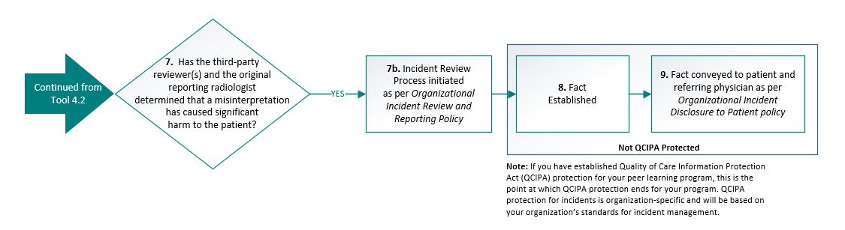
Figure 1: Incident Management Process Map

Note: In prospective peer review, any discrepancies will be modified before the report is sent to the referring physician/patient. It is therefore unlikely that harm, as defined by each organization, could reach the patient. You may decide that an incident management process is out of scope for your Diagnostic Imaging Peer Learning Program.
It is recommended that you consult with your legal/privacy office, as your organization may choose to classify prospectively identified discrepancies as a “near miss incident,” in which case, an incident management process should be developed.

4.4 Incident Management Process Steps
Action | Key Decision
Continued from tool 4.2 Discrepancy Management Process Map and Standard of Work
- Has the third-party reviewer(s) and the original reporting radiologist determined that a misinterpretation has caused significant harm to the patient? | - How does your organization define patient harm?  - How will consensus be reached?  - What are the next steps if consensus cannot be reached?  - Are there any documentation requirements? Who is responsible for documenting?  Implementation Recommendation: Refer to organizational policy for definition of patient harm.  For Cross-Organization Programs:  - The decision regarding patient harm should be made between the original reporting radiologist and third-party reviewer(s) from the organization where the imaging and report originated  - Definition of patient harm should be defined by the organization where the original imaging and report were completed
7b. If yes: Initiate the incident review process, as per your organization’s incident review and reporting policy | - What is the structure of the incident review process?  - Who will be responsible for communicating that an incident has occurred?
Exit Peer Learning Program Processes and Enter Organizational Incident Management Processes
- Fact established | - Who will establish the fact?  - What is the mechanism to ensure the fact has been appropriately documented in the patient chart (e.g., report addendum) as per organizational policy/standards?  Implementation Recommendation: The original reporting radiologist should establish the fact and document all corresponding information in the patient’s chart.  Note: If you have established Quality of Care Information Protection Act (QCIPA) protection for your peer learning program, this is the point at which QCIPA protection ends for your program. QCIPA protection for incidents is organization-specific and will be based on your organization’s standards for incident management.
- Fact conveyed to patient and referring physician as per your organization’s incident disclosure to patient policy | - When is patient disclosure required?  - What is the process to disclose the fact to the patient and referring physician?  Implementation Recommendation: This step will be specific to each participating organization. Please refer to your organization’s policy on incident disclosure to patients. Engage (1) the Patient Safety and Risk Management Office and (2) the patient relations team (if applicable) at the organization where the original imaging and report were completed to determine the appropriate communication method to the patient and referring physician.

4.4 Incident Management Process Map Standard of Work
Document your decisions from the questions posed on pages 2 to 3 in the Standard of Work template below. Once populated, this document can be used for training and communication purposes.

Key Roles in Incident Management Process:
- Patient Safety and/or Risk Management Office: Lead the organizational incident management process
- Original Reporting Radiologist: In the event of a validated discrepancy, the original reporting radiologist is required to convey the discrepancy to the patient and referring physician
- Quality Lead(s): Initiate the incident management process under the guidance of the Facility Patient Safety and Risk Management Office

4.4 Incident Management Process Steps
Action | Recommended Owner | When | Notes (document decisions from process map)
7. Has the third-party reviewer(s) and the original reporting radiologist determined that a misinterpretation has caused significant harm to the patient? | Original Reporting Radiologist & Quality Lead  Optional: Radiologist-in-Chief and/or Peer Learning Program Lead | Upon confirmation of discrepancy by third-party reviewer(s) and original reporting radiologist
7b. If yes: Initiative the incident review process, as per your organization’s incident review and reporting policy | Patient Safety and Risk Management Office | Upon consensus regarding patient harm resulting from report discrepancy
Exit Peer Learning Program Processes and Enter Organizational Incident Management Processes
8. Fact Established | Original Reporting Radiologist & Quality Lead  Optional: Radiologist-in-Chief and/or Peer Learning Program Lead | As determined through incident management process
- Fact conveyed to patient and referring physician as per your organization’s incident disclosure to patient policy | Original Reporting Radiologist  Patient Safety and Risk Management Office (if necessary, Patient Relations Office) | Once the fact is established
ISBN 978-1-4868-3789-2 (PDF)

© Queen’s Printer for Ontario, 2019

The copyright for all Health Quality Ontario publications is owned by the Queen’s Printer for Ontario. Materials may be reproduced for commercial purposes only under a licence from the Queen’s Printer. For further information or to request a licence to reproduce content, please contact:

Senior Copyright Advisor
Publications Ontario
416-326-5153
copyright@ontario.ca

