September 2019
Diagnostic Imaging Peer Learning Toolkit

5.3a Language to Update Organization-Level Quality Oversight Entity’s Terms of Reference

Note: The language in this tool should be customized to suit the needs of your organization.

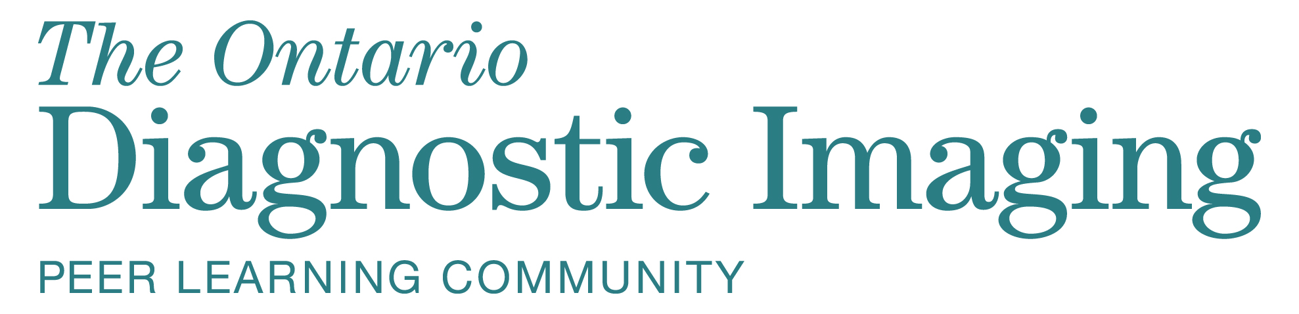

5.3a Language to Update Organization-Level Quality Oversight Entity’s Terms of Reference

To update the language in your organizational-level quality oversight entity’s terms of reference, please choose ONE of the options below.

Option 1 (if you DO NOT plan on enabling QCIPA protection)

You can use the following language to incorporate your peer learning program into your existing organizational-level quality oversight entity’s terms of reference for the purpose of establishing an accountability and reporting structure.

In accordance with delegated authority from the Organization-Level Quality Oversight Entity OR Name of Departmental Quality of Care Committee (optional), the Organization Name Diagnostic Imaging Peer Learning Program established hereunder is designated a quality of care committee.

“Quality of care information” is defined as information collected by, or prepared for, a quality of care committee, for the sole or primary purpose of assisting the committee in carrying out its functions; and/or information that relates solely or primarily to any activity that a quality of care committee carries out as part of its functions. Quality of care information reviewed, analyzed, presented, and/or discussed in the Organization-Level Quality Oversight Entity, or within the Diagnostic Imaging Peer Learning Program, is considered “privileged and confidential” and is used to assess, improve, or maintain the quality of care within an organization.

The role (e.g., Radiologist in Chief, Quality Lead, or Administrative Lead) will act as liaison between the Diagnostic Imaging Peer Learning Program and the Organization-Level Quality Oversight Entity.

Option 2 (language TO ENABLE QCIPA designation)

If it is decided that QCIPA designation will be enabled, you can incorporate the following language into your existing organizational-level quality oversight entity’s terms of reference. See tool 5.3b Quality of Care Committee Terms of Reference Template if you need to establish a new departmental Quality of Care Committee.

In accordance with delegated authority from the Organization-Level Quality Oversight Entity, Organization Name, the Diagnostic Imaging Peer Learning Program established hereunder is designated a sub-committee of the Organization-Level Quality Oversight Entity OR Name of Departmental Quality of Care Committee (optional) under the Quality of Care Information Protection Act, 2016.

“Quality of care information” is defined as information collected by or prepared for a quality of care committee for the sole or primary purpose of assisting the committee in carrying out its functions; and/or information that relates solely or primarily to any activity that a quality of care committee carries out as part of its functions. Quality of care information reviewed, analyzed, presented, and/or discussed in the Organization-Level Quality Oversight Entity or in the Name of Departmental Quality of Care Committee (if applicable) within the Diagnostic Imaging Peer Learning Program is considered “privileged and confidential” and is used to assess, improve, or maintain the quality of care within an organization.

The role (e.g. Radiologist in Chief, Quality Lead, or Administrative Lead) will act as liaison between the Diagnostic Imaging Peer Learning Program and the Organization-Level Quality Oversight Entity.

ISBN 978-1-4868-3789-2 (PDF)

© Queen’s Printer for Ontario, 2019

The copyright for all Health Quality Ontario publications is owned by the Queen’s Printer for Ontario. Materials may be reproduced for commercial purposes only under a licence from the Queen’s Printer. For further information or to request a licence to reproduce content, please contact:

Senior Copyright Advisor
Publications Ontario
416-326-5153
copyright@ontario.ca

